
Student Number
Mark /

Chemistry Assessment

Task 3 Term 2 2009 Part 1. Theory

General Instructions

Theory and Research

•Reading time – 5 minutes
•Working time – 110 minutes
•Write using black or blue pen
•Write your Student Number at the top of this page
•Board-approved calculators may be used

A data sheet and a periodic table are provided
at the back of the paper.

Total Marks – 46

Part A – 8 marks

Attempt Questions 1-8
Allow about 5 minutes for this part

Part B – 38 marks

Attempt Questions 9-16
Allow about 45 minutes for this part

Part B – 28 marks

Confidential
Keep Secure

Part A: Multiple Choice: 8 marks
Attempt Questions 1-8
Allow about 5 minutes for this part

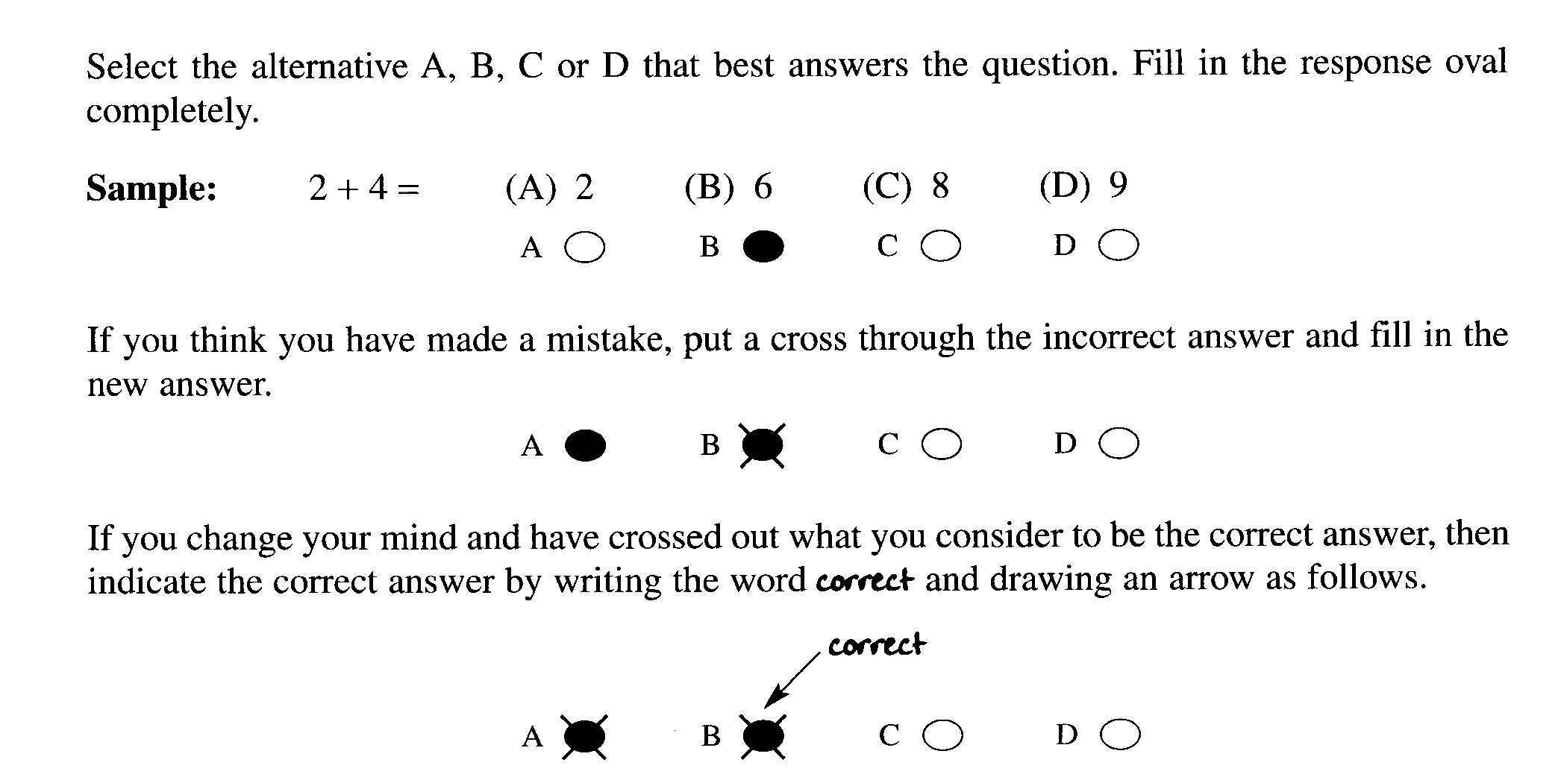

Mark your answers for the multiple choice questions in the multiple choice grid on page -----

1. The structural formula for a haloalkane is shown.

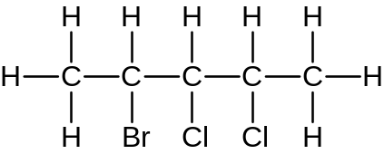

What is the IUPAC name of an isomer for this haloalkane?

(A) 2-bromo-3,4-dichloropentane

(B) 4-bromo-2,3-dichloropentane

(C) 2-bromo-3,3-dichloropropane

(D) 1-bromo-3,3-dichloropentane
The question asks for the isomer!

2. Which option lists the layers of the atmosphere in the descending order.

(A) thermosphere, mesosphere, stratosphere, troposphere

(B) troposphere, mesosphere, stratosphere, thermosphere

(C) stratosphere, mesosphere, troposphere, thermosphere

(D) thermosphere, stratosphere, troposphere, mesosphere

Outcome: H13

3.. The table shows the major tropospheric air pollutants and their sources. Which of the items in the list is incorrect?

Pollutant | Source
(A) ozone | diffusion from the stratosphere
(B) airborne lead | lead smelters
(C) sulfur dioxide | metal smelters
(D) hydrocarbons | vehicles and factories using solvents
Outcome:H4, H13

4. A student performed some tests to identify the cations of three nitrates,
solutions P, Q and R. Her observations are described below :

Solution P : A white precipitate formed with sodium sulfate solution.
A brick-red colour resulted when solution P was sprayed in a Bunsen flame.

Solution Q : A yellow precipitate formed with potassium iodide solution.
No colour change was observed when solution Q was sprayed into the Bunsen flame.

Solution R A blue precipitate formed with sodium hydroxide solution.. A blue-green colour
was observed when solution R was sprayed into a Bunsen flame.

What are the cations present in each of solutions P, Q and R ?

(A) calcium, sodium, barium

(B) barium, sodium, copper

(C) barium, lead, copper

(D) calcium, lead, copper

5. Which of the following solutions can be used to determine the presence of carbonate ions in
a compound?

(A) dilute silver nitrate solution

(B) dilute sodium sulfate solution

(C) dilute nitric acid solution

(D) dilute barium nitrate solution

6. Consider the following reaction

2A (g) + 3B (g) 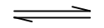 C (aq) + 4D (aq)

Which correctly represents the equilibrium expression?

(A) [A]² [B]³
[C] [D]⁴

(B) [C] [D]⁴

(C) [C] [4D]
[2A] [3B]

(D) [C] [D]⁴
[A]² [B]³

7. Which of the following best describes the industrial reaction conditions for the Contact Process?

(A) 450⁰C V₂O₅ catalyst 2 atm

(B) 450⁰C V₂O₅ catalyst 200 atm

(C) 550⁰C Fe₃O₄ catalyst 2 atm

(D) 550⁰C Fe₃O₄ catalyst 200 atm

8. Which of the following shows sulfuric acid acting as an oxidizing agent?

(A) C₁₂H₂₂O₁₁ + 11H₂SO₄ 12C + 11H₂SO₄ . H₂O

H₂SO₄
(B) C₂H₅OH CH₂=CH₂ + H₂O

(C) Ca₃(PO₄)₂ (s) + 3H₂SO₄ 3CaSO₄ (s) + H₃PO₄

(D) Cu (s) + 2H₂SO₄ Cu ²⁺ + SO₄ ²⁻ + 2H₂O + SO₂ (aq)

Part A . Answer grid for multiple choice questions Total ................/8...

1. A O B O C O D 

2. A  B O C O D O

3. A  B O C O D O

4. A O B O C O D 

5. A O B O C  D O

6. A O B O C O D 

7. A  B O C O D O

8. A O B O C O D 

Part B Free Response Questions

Attempt Questions 9- 16
Allow about 45 minutes for this part

Show all relevant working in questions involving calculations.

Question 9 (3 marks)

(a) Two molecules are shown.

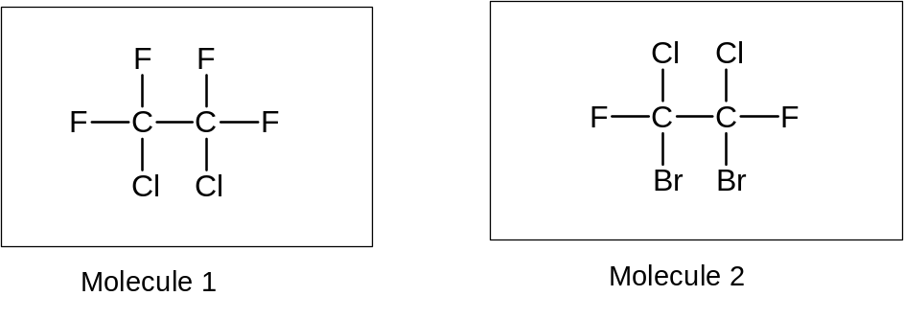

Identify which molecule would be classified as a halon. (1 mark)

....................................................................................................................................................
Answer
Molecule 2

(b) Identify a possible source of halons in the atmosphere (1 mark)

....................................................................................................................................................

Answer:

Sources of halons include: fire extinguishers,

(c) Describe one use of chlorofluorocarbons. (1 mark)

....................................................................................................................................................

Answer:

CFCs may be used as refrigerants, aerosol propellants,

Question 10 (5 marks)

(a) Explain with the aid of chemical equations why chlorofluorocarbons are harmful to the ozone layer. (3 marks)

....................................................................................................................................................

....................................................................................................................................................

....................................................................................................................................................

....................................................................................................................................................

....................................................................................................................................................

....................................................................................................................................................

Sample Answer

CCl₃F + UV light → Cl + •CCl₂F

Cl + O₃ → ClO + O₂

ClO + O → O₂ + Cl

Chlorofluorocarbons may react to form chlorine atoms which react with ozone, forming oxygen and chlorine oxide. This process can continue since the chlorine atom is regenerated from chlorine oxide reacting with oxygen atoms to form oxygen molecules and chlorine.

Outcome criteria | Marks
Two chemical equations provided. | 2
One chemical equation provided. | 1

(b) Assess the effectiveness of the processes used to prevent the destruction of the ozone layer.
(3 marks)

....................................................................................................................................................

....................................................................................................................................................

....................................................................................................................................................

....................................................................................................................................................

....................................................................................................................................................

....................................................................................................................................................

....................................................................................................................................................

....................................................................................................................................................

Sample Answer

Process 1: phasing out of the use of CFCs and halons via the Montreal Protocol. This has been successful since the amount of CFCs released has been decreasing since the introduction of the Montreal Protocol.

Process 2: replacement of CFCs and halons with hydrofluorocarbons which do not form chlorine atoms in the upper atmosphere. This has been successful since most processes that use CFCs and halons now use HFCs.

Outcome criteria | Marks
Describes two processes used to prevent the destruction of the ozone layer. Assesses the effectiveness of one of the processes in reducing the destruction of the ozone layer. | 3
Describes two processes used to prevent the destruction of the ozone layer. | 2
Describes one process used to prevent the destruction of the ozone layer. | 1

Question 11 (3 marks)

Explain the effect of ozone in the stratosphere. Include a relevant chemical equation.

................................................................................................................................................

.............................................................................................................................................

.............................................................................................................................................

.............................................................................................................................................

.............................................................................................................................................

............................................................................................................................................

............................................................................................................................................

............................................................................................................................................

.
Outcomes: H7, H13

Answer:

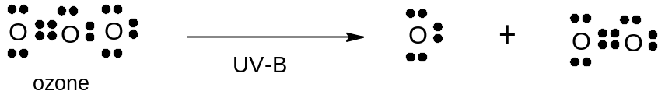
or
O₃ 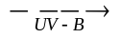 O + O₂

High energy UV radiation such as UV-C and UV-B are extremely harmful to living cells, causing cancer growth etc . Without ozone, life cannot exist on Earth. Oxygen filters off the UV- C, ozone, in turn, filters off UV-B resulting in its decomposition to oxygen. UV-A, the lowest energy UV, passes through the atmosphere unchanged through to the troposphere where it may be useful in small quantities in synthesising Vitamin D in the body.

Criteria | Marks
Equation showing destruction of ozone by UV-B. (Lewis structure is not required). | 1
Explanation of how this destruction is useful to life on earth. (filters off harmful UV light, etc) | 1
Effect of ozone on life in the troposphere. | 1

Question 12 (5 marks)

Assess the role of determining dissolved oxygen and biochemical oxygen demand on ensuring the maintenance of a healthy waterway.

..............................................................................................................................................

..............................................................................................................................................

..............................................................................................................................................

..............................................................................................................................................

..............................................................................................................................................

..............................................................................................................................................

..............................................................................................................................................

..............................................................................................................................................

..............................................................................................................................................

..............................................................................................................................................

..............................................................................................................................................

..............................................................................................................................................

Outcomes: H16, H13
ANS:

A healthy waterway consists of water fit as a source of drinking water (after proper treatment) and which supports diverse lifeforms such as various kinds of plants and fishes.
(D) Dissolved oxygen is a measure of the concentration of oxygen dissolved in the water in mg/L.
(ID)The need for oxygen among organisms differ. The more oxygen dissolved, the more types of organism are able to survive. Low dissolved oxygen limits diversity in the waterway.
(B)The biochemical oxygen demand (BOD) is a measure of the requirement for oxygen of the organic materials in the water.
(IB) A polluted waterway will have a large amount of organic material and therefore will require more oxygen and hence higher BOD.

(A) BOD measurement, therefore, has a critical role in determining the suitability of water for household use after purification and also it is critical in determining the continuing health of the water, and the variety of organisms able to survive in the the waterway, i.e., a measure for the tendency for eutrophication.

Criteria | Marks
statement of what dissolved oxygen is and what biochemical oxygen demand is | 2
statement of the importance of dissolved oxygen and biochemical oxygen demand in assessing water quality | 2
an explicit statement of the important role of DO and BOD measurement in determining the health of a waterway | 1

Question 13( 5 marks)

A student carried out a first-hand investigation to analyse the sulfate content of lawn fertilizer consisting of ammonium sulfate. The student weighed out 2.00 g of fertilizer and dissolved it in
water. The student then added 50.0 mL of 0.25 molL⁻¹ barium chloride solution to the dissolved fertilizer. A white precipitate of barium sulfate formed. After filtering and drying the
barium sulfate weighed 1.8g

(a) Calculate the percentage by mass of sulfate in the fertilizer (2 marks)

..................................................................................................................................................

..................................................................................................................................................

..................................................................................................................................................

..................................................................................................................................................

..................................................................................................................................................

..................................................................................................................................................

Sample Answer

n(BaSO₄) = 1.8 / 233.37 = 7.7 X 10⁻³ mol
n(SO₄²⁻) = n(BaSO₄) = 7.7 x 10⁻³ mol (1 mark)
m(SO₄²⁻) = 7.7 X 10⁻³ X 96.07 = 0.74g

%mass SO₄²⁻ = (0.74 / 2.00) X 100 = 37% (1 mark)

Marking Criteria
Criteria | Mark
Correct calculation of % mass sulfate in fertilizer and correct calculation of moles of Barium sulfate and thus sulfate ions. | 2
Correct calculation of moles of barium sulfate and thus moles of sulfate ions. | 1

(b) In your practical work you carried out the analysis of sulfate in ammonium sulfate
fertiliser. In the light of this work, evaluate the accuracy and reliability of the results
from the above first-hand investigation (4 marks)

..............................................................................................................................................

..............................................................................................................................................

..............................................................................................................................................

..............................................................................................................................................

..............................................................................................................................................

..............................................................................................................................................

..............................................................................................................................................

..............................................................................................................................................

Sample answer

The accuracy of the results may have been affected by a number of factors including the level of solubility of the fertilizer; acid should have been added to assist the dissolving of the fertilizer. Barium sulfate is a very fine precipitate and most of it would have passed through filter paper if it had been used. The use of a sintered glass funnel would have captured a greater amount of the barium sulfate residue. The results would be more reliable if repeat trials had been conducted using the same procedure.

Marking criteria
Criteria | Mark
Evaluates the accuracy and reliability of the results of the first-hand investigation with suggestions of improvements (?) | 4
Describes the accuracy and reliability of the results | 2
Describes accuracy or reliability of the first-hand investigation | 1

Question 14 (3 marks)

Assess the impact of atomic absorption spectroscopy (AAS) on the scientific understanding of the effects of trace elements.

.............................................................................................................................................................

.............................................................................................................................................................

.............................................................................................................................................................

.............................................................................................................................................................

.............................................................................................................................................................

.............................................................................................................................................................

.............................................................................................................................................................

.............................................................................................................................................................

.............................................................................................................................................................

.............................................................................................................................................................

.............................................................................................................................................................

Sample Answer

AAS spectroscopy is used to measure the concentration of metal ions to ppm or ppb. Trace elements are needed in very small amounts by living things. Zinc,copper and iron are all trace elements found in soil and limited amounts can affect agricultural productivity. Thus AAS has allowed monitoring of levels of trace elements in the soil to levels not possible before. If levels are too low chemicals can be added to the soil to increase the amounts of the trace elements.

Marking Criteria
Criteria | Mark
Assesses the impact of AAS on the understanding of the effects of trace elements. | 3
Describes the impact of AAS on the scientific understanding of the effects of trace elements | 2
Describes AAS or identifies trace elements | 1

Question 15 (6 marks)

Sulfuric acid is the most produced industrial chemical in the world.

Complete the following table to account for the provided information about the storage and handling of sulfuric acid.

Information | Explanation
When diluting sulfuric acid, always add acid to water.
Concentrated sulfuric acid can be stored in steel containers.
Protective clothing and eyewear must be worn when using sulfuric acid.

Answer

Sulfuric acid is the most produced industrial chemical in the world.

Complete the following table to account for the provided information about the storage and handling of sulfuric acid. (6 marks)

Sample Answers

Information | Explanation
When diluting sulfuric acid, always add acid to water. | The ionization of sulfuric acid is exothermic, releasing lots of heat energy. If water is added to concentrated sulfuric acid, the heat released will make the solution boil violently, splattering drops of acid. Adding acid to water helps to dissipate the heat in a larger volume.
Concentrated sulfuric acid can be stored in steel containers. | Concentrated sulfuric acid occurs mostly as intact molecules, thus there are hardly any hydrogen ions present to react with the steel.
Protective clothing and eyewear must be worn when using sulfuric acid. | Acid is corrosive and can cause burning to the skin and eyes. Wash off any acid immediately.

Outcomes : H11, H8, H7, H3, H4

Marking Criteria | Marks
- Explains the implications of all three situations | 4 -6
- Outlines the implications of all three situations | 3
- Explains one situation or gives a brief outline | 2
- Outlines one situation | 1

Question 16 (6 marks)

Phosgene is produced from chlorine and carbon monoxide according to the following reaction.

CO (g) + Cl₂ (g)  COCl₂ (g)

When CO and Cl₂ are mixed in the presence of activated carbon, the concentration of each gas change according to the graph below.

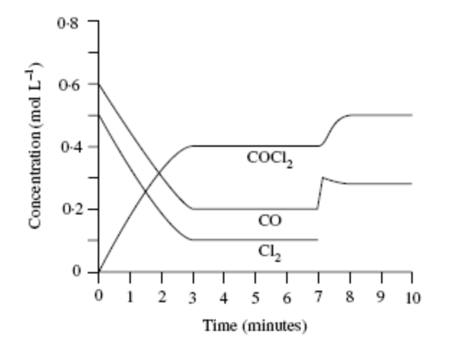

(a) Calculate the equilibrium constant for the reaction at 5 minutes. (2 marks)

.................................................................................................................................................

.................................................................................................................................................

.................................................................................................................................................

(c) On the graph, sketch the change in concentration of chlorine after the
7 minute mark (1 mark)

(d) Explain the changes to the graph after the 7 minute mark . (3 marks)

.................................................................................................................................................

.................................................................................................................................................

.................................................................................................................................................

.................................................................................................................................................

.................................................................................................................................................

.................................................................................................................................................

.................................................................................................................................................

.................................................................................................................................................

Answer
Phosgene is produced from chlorine and carbon monoxide according to the following reaction.

CO (g) + Cl₂ (g)  COCl₂ (g)

When CO and Cl₂ are mixed in the presence of activated carbon, the concentration of each gas change according to the graph below.

(a) Calculate the equilibrium constant for the reaction at 5 minutes. (2 marks)

K = [COCl₂] (1 mark) = 0.4 = 20 (1 mark)
[CO][Cl₂] 0.2 x 0.1

(c) Sketch the change in concentration of chlorine on the graph after the 7 minute mark (1 mark)

(d) Explain the changes to the graph after the 7 minute mark . (3 marks)

Sample Answer

At the 7 minute mark, CO was added to the system. Equilibrium shifted to oppose the change (Le Chatelier), ie to use up some CO. The concentration of CO decreased from the added amount, Cl₂ decreased and COCl₂ increased and equilibrium shifted to the right.

Marking Criteria | Marks
- Identifies added CO and explains in terms of Le Chatelier | 3
- Identifies added CO and outlines equilibrium shift | 2
- Identifies added CO or explains equilibrium shift | 1

End of Theory Test

